Design Documentation

CONTENTS

1. Overview
2. CPU Benchmark
3. MEMORY Benchmark
4. DISK Benchmark
5. Trade Off
6. Other files
7. Future Scope
8. Design diagram
___________________________________________________________________________________
1. Overview
Benchmark: “Benchmarking is a concept of comparing business process and performance metrics”.
Here we are trying to develop our own benchmarking programs those will try to measure performance of CPU, MEMORY and DISK. The idea is to give as much as varying load to each of these Computer parts on an Amazon AWS EC2 t2.micro instance. All these benchmark codes are written in C. The reason for this is, C can directly communicate instructions unlike intermediate language such as Java.

2. CPU Benchmark
In this benchmark, we are performing overall 2*3+1*2 = 8 experiments to measure CPU performance. We will first load the instructions of Integer operations and then Floating point operations. We will compute time taken for these instructions separately. This is done to check whether datatype of operands plays any role in CPU performance. We will measure the time taken for running those 100000000 instructions and this we will use in computing GIOPS and GFLOPS.
GIOPS : Giga Integer Operations Per Second
GFLOPS : Giga Floating point Operations Per Second
In the second experiment we are running the Integer and Floating point instructions continuously for 10 minutes. i.e. 600 seconds separately. For each second we are recording number of operations performed by the CPU. In all this program will run for 20 minutes. Then we will compute GIOPS and GFLOPS for each second. We are running 4 threads hence 600*4 samples will be collected. Performance will be measured by adding operations performed by each thread. This we will use as OPS (operations per second) to compute our GFLOPS and GIOPS.
3. MEMORY Benchmark
In this benchmark, we will measure the performance of main memory of CPU. For this we are performing total : 1*2*3*2 = 12 experiments of varying concurrency, blocksize and access mode(sequential, random). We will load the memory with a buffer and copy it with varying blocksize instructions. This is again performed with concurrent threads and different access modes in order to observe whether concurrency and access mode effects Memory performance.
We will measure the total time taken for memcpy() some data. Then we will calculate memory bandwidth (Throughput) as : Data/Time (in mbps).
We will also measure latency for these instructions in milliseconds..

4. DISK Benchmark
Just like MEMORY, here we are measuring performance of DISK. To ensure disk operations, we will deal with File operations. However, performance measure methods and units will remain same as MEMORY. We are taking a 60mb file I.pdf to perform read and write operations of varying blocksize, varying concurrency, varying access mode (sequential, random).

5. Trade Off
To keep ensure all threads have completed their execution, code will wait for all of them to join. However, it is not ensured that they all started at same time. Taking average time of each thread was another option. But I made a trade off by starting all threads and waiting for all of them to join.
6. Other files
I.pdf: This is a sample file used for DISKBenchmark. We can use any file in place of this file. However, the name must be I.pdf. You can change this name inside DISKBenchmark.c code at the very start. It is defined as :
#define fileName "I.pdf"
batch.sh: This file contains automated script for running all the benchmarks without much of human interference required. Once you execute this file, you will get all the outputs stored in separate files of each benchmark.
7. Future Scope
We can add few more extensions like writing logs. There are few ways of detecting what other aspects are using MEMORY/DISK or CPU. We can check how much utilization is that in order to improve the precision of of our benchmark.

8. Design diagram
Below is the architecture diagram of how control flows and which file deals with what region:

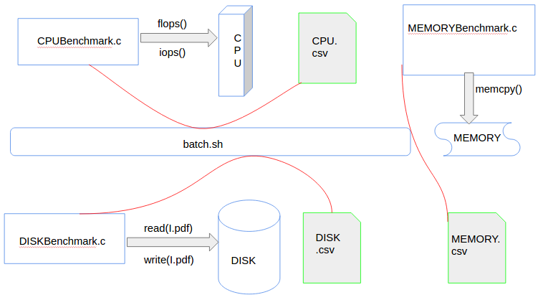
fig 1. Architecture diagram of Programming assignment 1

